Exercise Solution

Task - 01
1. What happens to the LED when both inputs are set to `0`.Attach the screen shot?

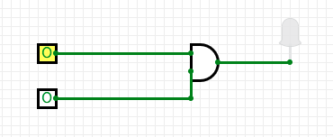
EXPLANATION:
When both inputs in ‘AND’ gate are set to ‘0’. The output is ‘0’, and the bulb remains switched off.

Task – 02
Describe the behavior of the AND gate when only one input is `1`. Attach the screen shot?

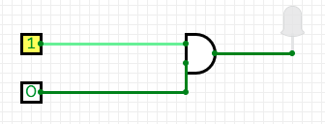
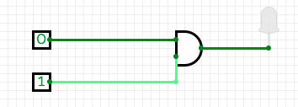

EXPLANATION:
When any of the input in ‘And’ gate is set to ‘1’ and other to ‘0’, the output still is zero and the bulb remains switched off.

Task-03
How would the output change if you used an OR gate instead of an AND gate?
INPUT:

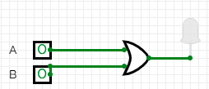
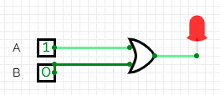

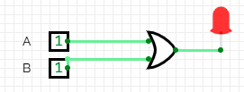
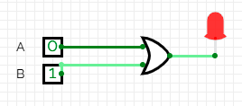

EXPLANATION:
Below is the truth table for or gate, the bulb gets switched on when the output results ‘1’. The ‘or’ gate results into ‘0’ only when both the input are ‘0’ i.e. low, otherwise it results into 1(i.e. gets high).

A | B | A or B
0 | 0 | 0
0 | 1 | 1
1 | 0 | 1
1 | 1 | 1

Task-04
Implement OR, NOT, XOR, NAND, XNOR and NOR gate and attach the screenshots of every combination of inputs

NOR:

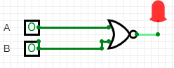

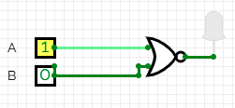
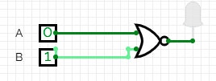

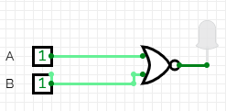

EXPLANATION:
Below is the truth table for nor gate, it is the total opposite of ‘or’ gate it results into 1 only when both the input are ‘0’, otherwise it results into ‘0’.

A | B | A nor B
0 | 0 | 1
0 | 1 | 0
1 | 0 | 0
1 | 1 | 0

NAND:

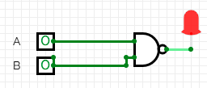
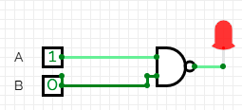

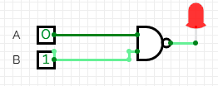
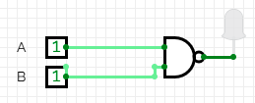

EXPLANATION:
Below is the truth table for nand gate, this is the opposite of and gate. It results into ‘0’ only when both input are ‘1’ otherwise ity gets high.

A | B | A or B
0 | 0 | 1
0 | 1 | 1
1 | 0 | 1
1 | 1 | 0

XNOR

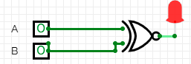

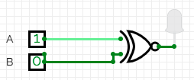

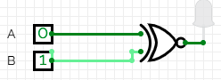

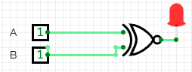

EXPLANATION:
Below is the truth table for xnor gate, it results into ‘0’ for opposite inputs and gets high(i.e. results into 1) for same inputs.

A | B | A or B
0 | 0 | 1
0 | 1 | 0
1 | 0 | 0
1 | 1 | 1

XOR:

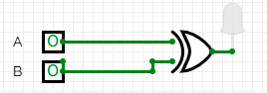

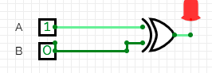
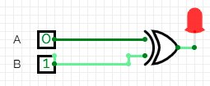

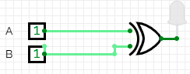

EXPLANATION:
Below is the truth table for xor gate, it results ‘0’ for same inputs otherwise it gets high for opposite input.

A | B | A or B
0 | 0 | 0
0 | 1 | 1
1 | 0 | 1
1 | 1 | 0

NOT

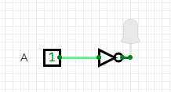

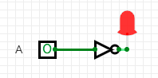

EXPLANATION:
Below is the truth table for not gate, it results into output that is opposite of the input.

A | NOT A
0 | 1
1 | 0

